**MAPPA DI COMUNITA’ (link del sito dove visionare articolo** [**https://www.icmariangelamontanari.edu.it/mappa-di-cominita/**](https://www.icmariangelamontanari.edu.it/mappa-di-cominita/) **)**

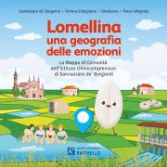 <https://drive.google.com/drive/folders/1OXV--BRLXW-dAcgUbjgVil-2Z84Vco6L>

Lomellina_Book_INT_2202_p39 <https://drive.google.com/drive/folders/1OXV--BRLXW-dAcgUbjgVil-2Z84Vco6L>